Nom: _____________________________________
Date: _____________________________________
Classe: _____________________________________

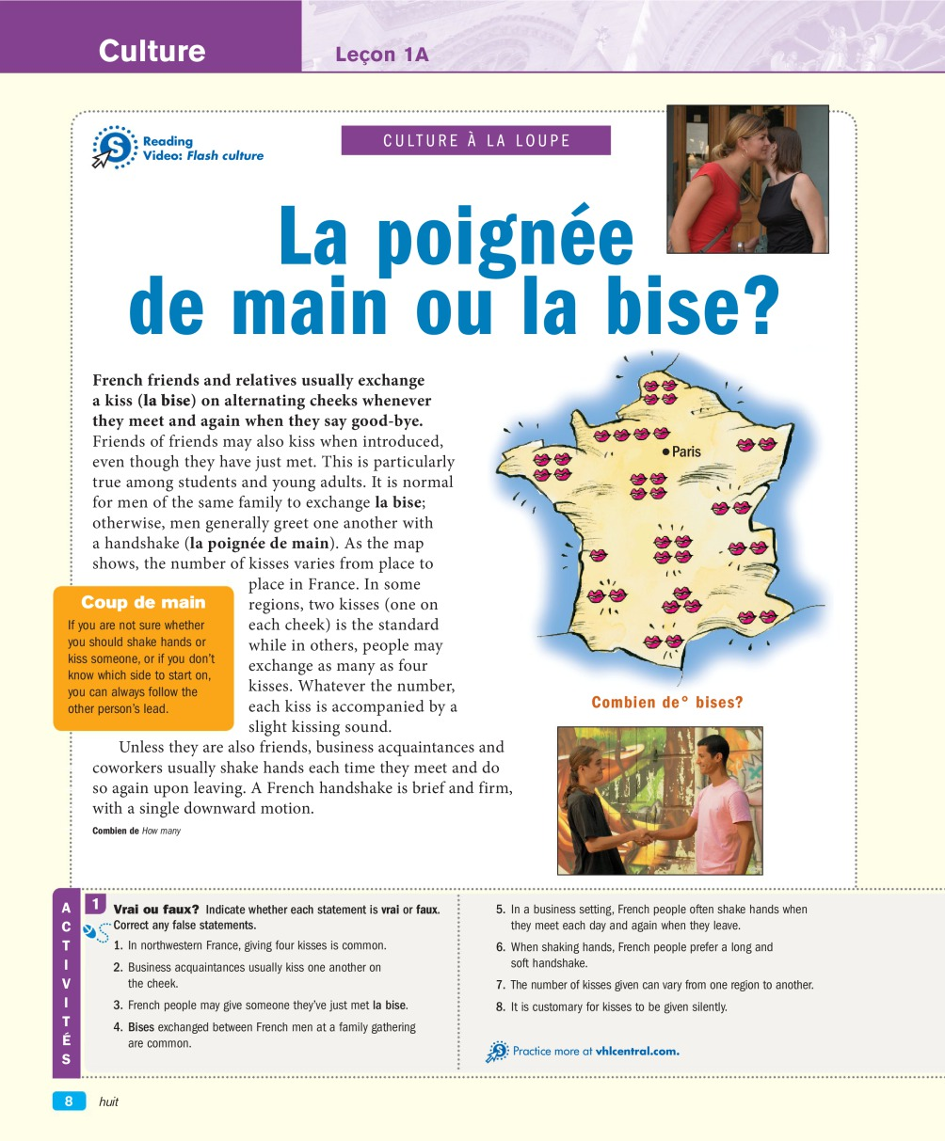
1/ Vrai ou Faux? (True or False)
1.
2.
3.
4.
5.
6.
7.
8.

2/ Culture: Highlight in yellow the correct answer
1. How do women say hello to each other in an informal situation?
A They give each other a hug.
B They kiss each other on the cheek.
C They shake hands.
2. How do men usually say hello to each other in an informal situation?
A They give each other a hug.
B They kiss each other on the cheek.
C They shake hands.
3. How do family members greet each other?
A They give each other a hug.
B They kiss each other on the cheek.
C They shake hands.
4. How do the two women at the office (formal situation) introduce each other?
A. They shake hands.
B They give each other a hug.
C They kiss each other on the cheek.
5. Can you guess how two men introduce each other in a formal situation?
A They give each other a hug.
B They kiss each other on the cheek.
C They shake hands.
3/ Questions
1. A classmate introduces you to his father.
A shake hands
B kiss on the cheek
2. You greet a girl you met in one of your classes.
A shake hands
B kiss on the cheek
3. You are introduced to a friend's girlfriend.
A shake hands
B kiss on the cheek
4. You arrive for a job interview and meet your potential new boss.
A shake hands
B kiss on the cheek
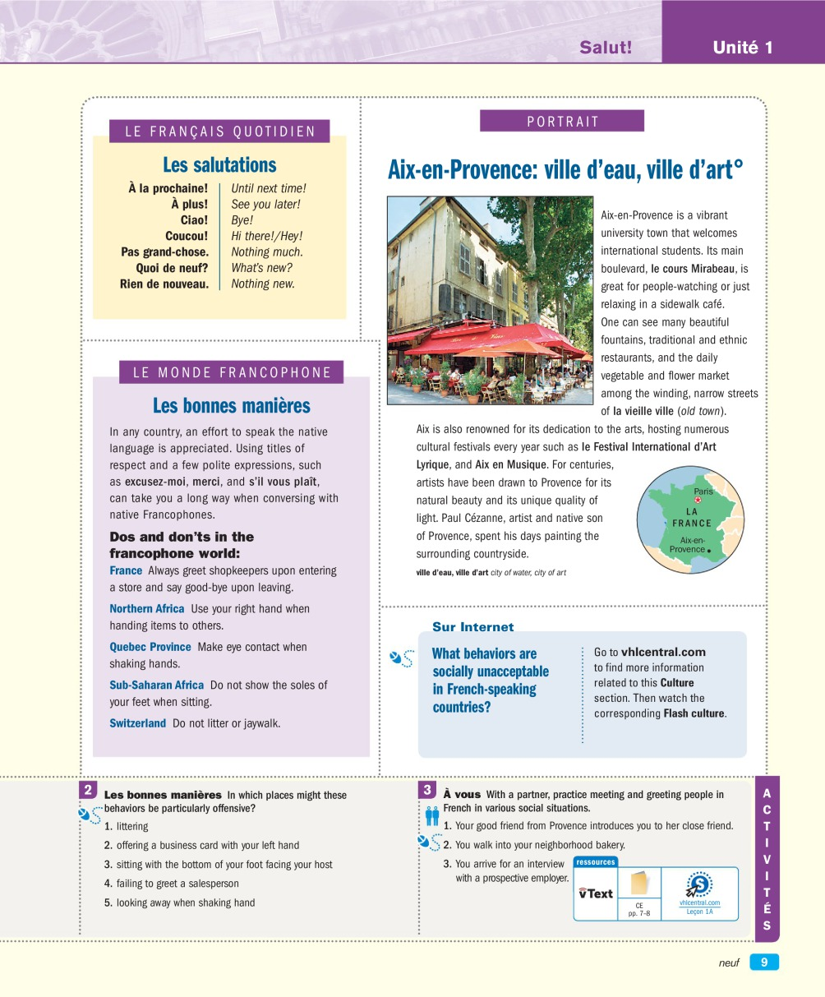
1/ Choisissez / Multiple choice Activity Choose the item from each list that you most associate with Aix-en-Provence. Highlight in yellow the correct answer.
1. skiing
A Claude Monet
B high rise buildings
C international students
2. les Champs-Élysées
A le cours Mirabeau
B la rue de Rivoli
C Avenue de Gaulle
3. Paul Gauguin
A Auguste Renoir
B Auguste Rodin
C Paul Cézanne

4. English influence
A surfing
B relaxing in a sidewalk café
C watching a concert in the historic amphitheater

2/ Vrai ou faux? (True or False)

Multiple choice Activity

1. In northwestern France, giving four kisses is common.
vrai
Faux

2. Business acquaintances usually kiss one another on the cheek.
vrai
Faux

3. French people may give someone they've just met la bise.
vrai
Faux

4. Bises exchanged between French men at a family gathering are common.
vrai
Faux

4. In a business setting, French people often shake hands when they meet each day and again when they leave.
vrai
Faux

4/ Les bonnes manières / Good manners
In which places might these behaviors be particularly offensive?
- Littering _______________________________________________
- offering a business card with your left hand _______________________________________________
- sitting with the bottom of your foot facing your host _______________________________________________
- failing to greet a salesperson _______________________________________________
- looking away when shaking hands _______________________________________________
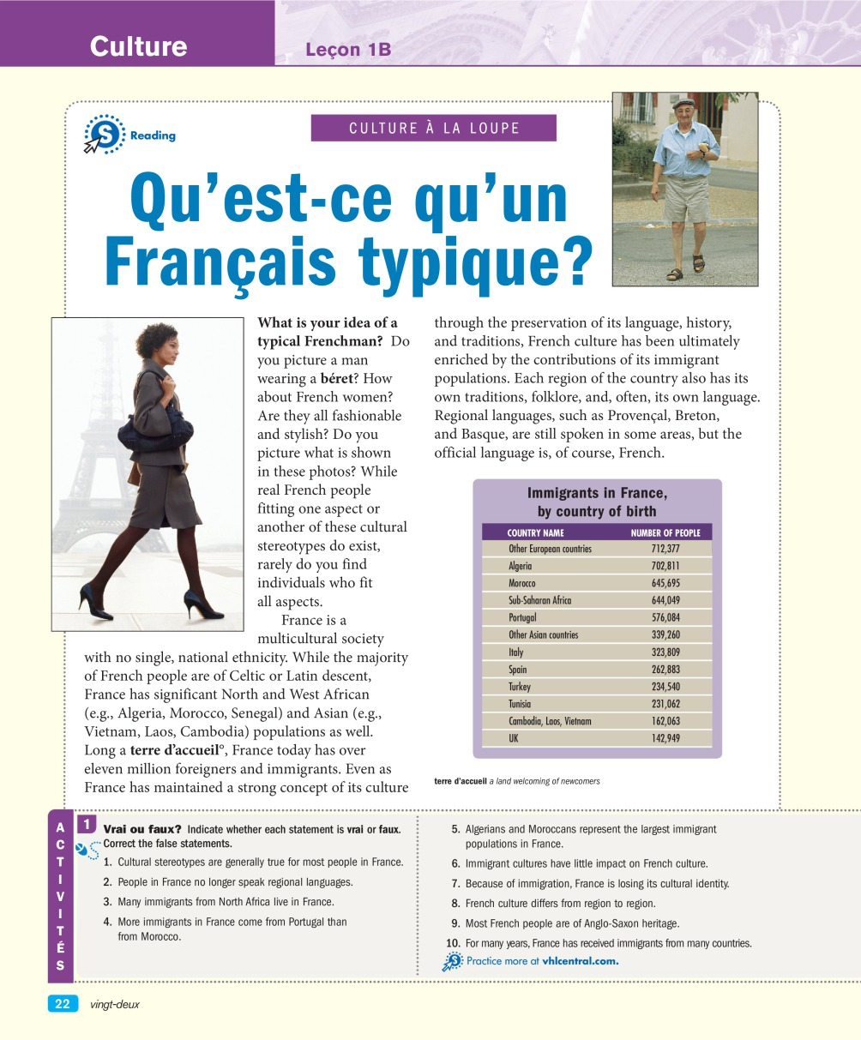

1/ Vrai ou Faux (True or False)
1.
2.
3.
4.
5.
6.
7.
8.
9.
10.

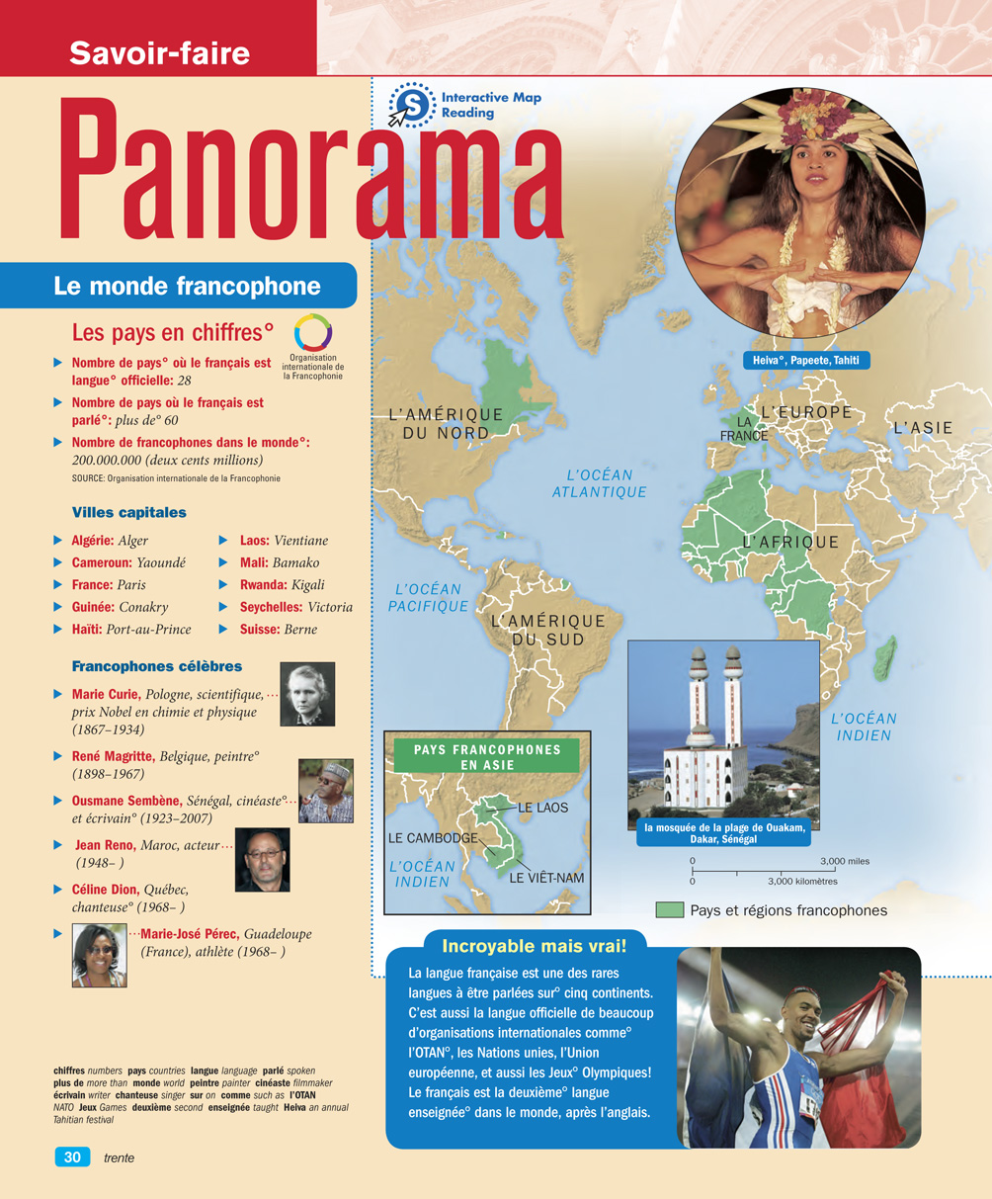

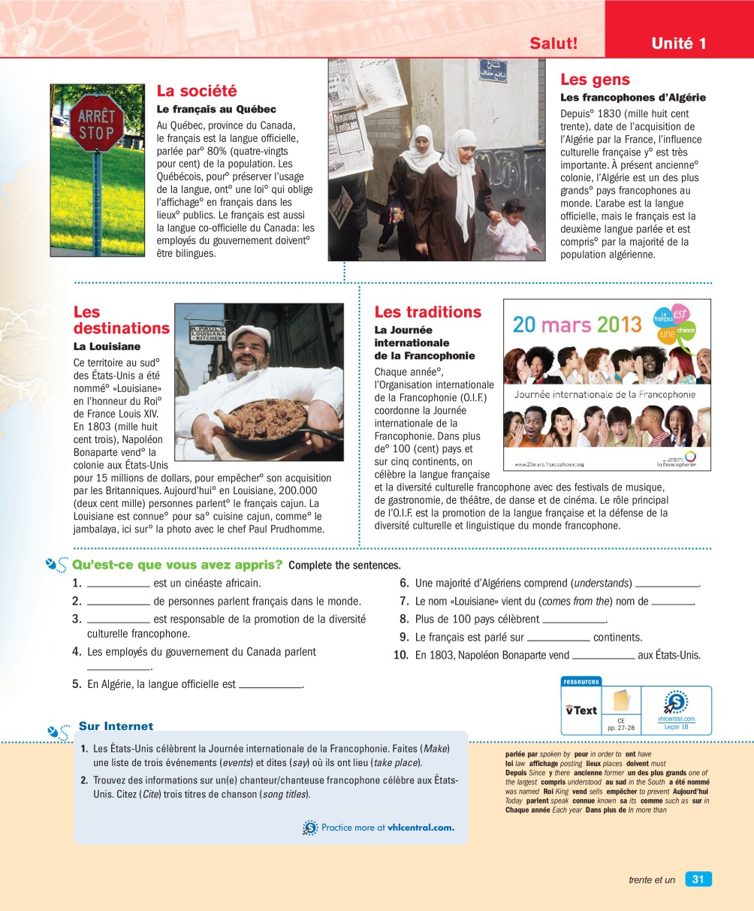

Qu'est-ce que vous avez appris?

1.
2.
3.
4.
5.
6.
7.
8.
9.
10.

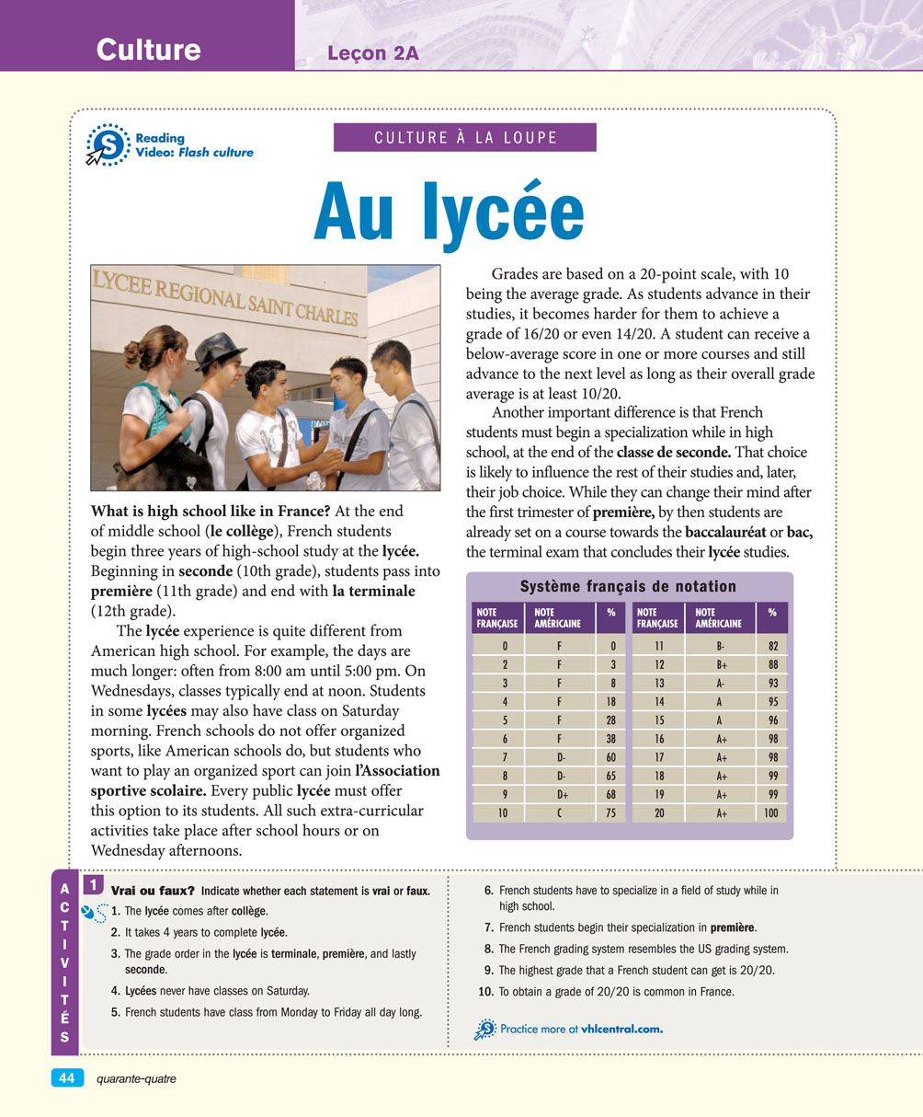

1/ Vrai ou Faux (True or False)
1.
2.
3.
4.
5.
6.
7.
8.
9.
10.

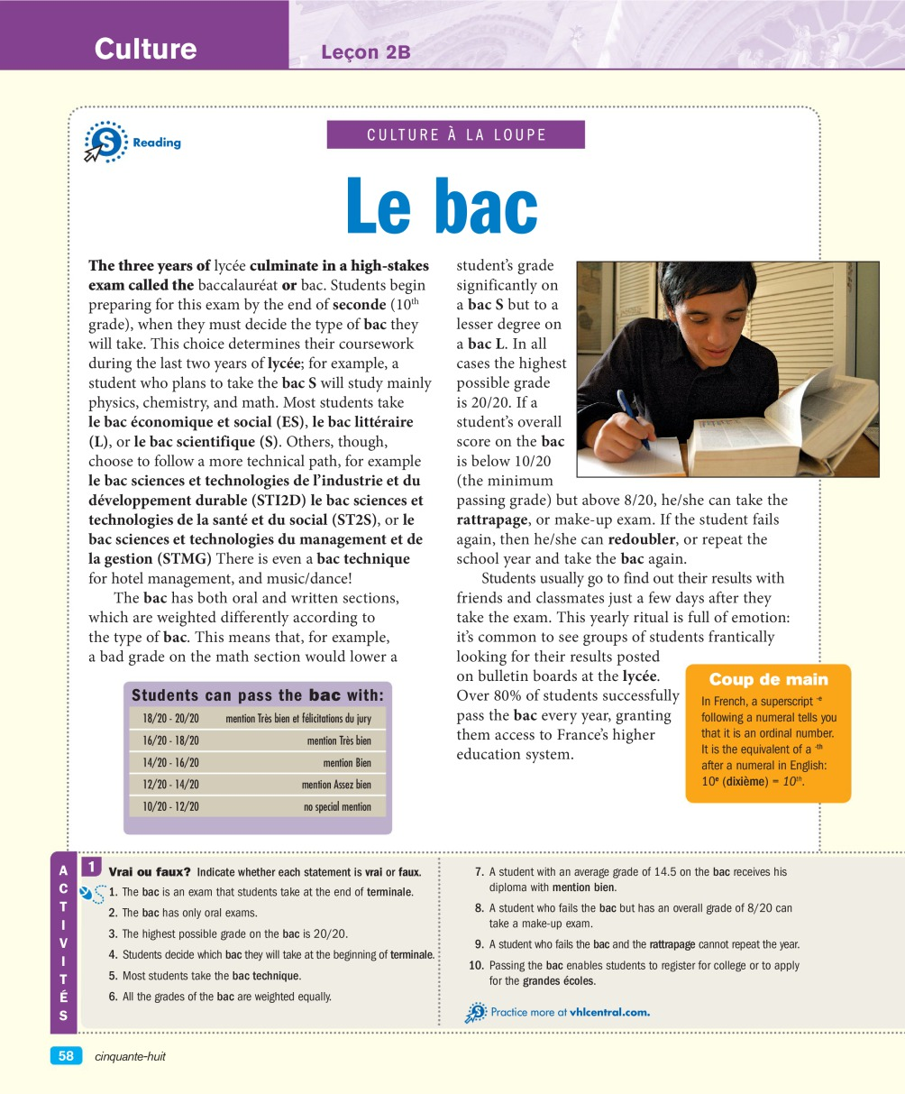

1/ Vrai ou Faux (True or False)
1.
2.
3.
4.
5.
6.
7.
8.
9.
10.

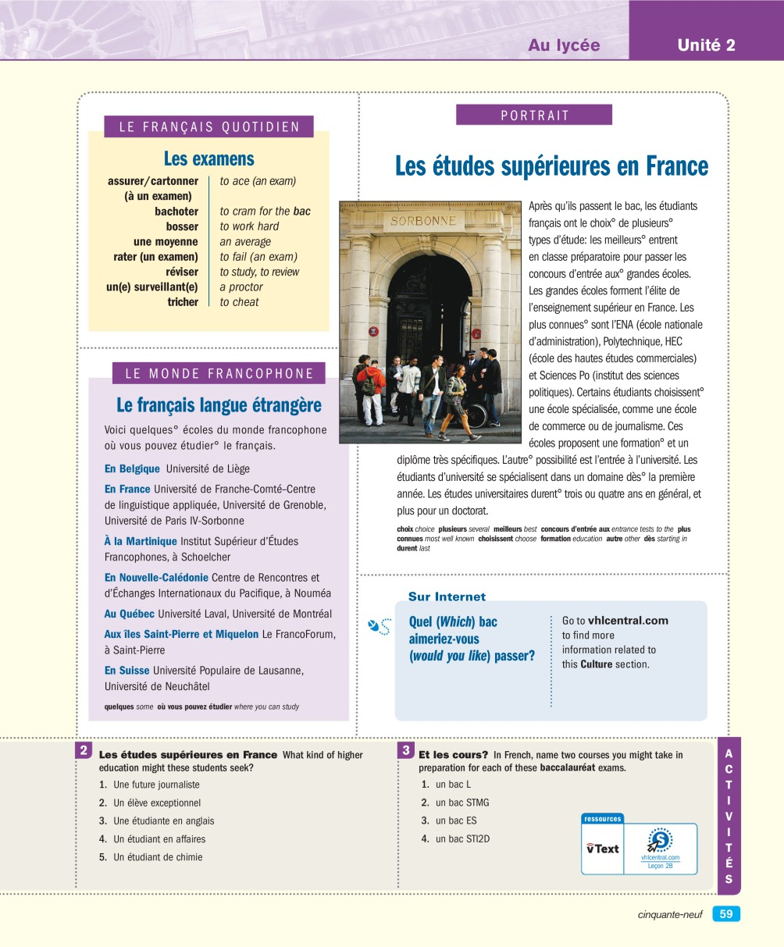

Les études supérieures en France

1.
2.
3.
4.
5.

Et les cours?

1.
2.
3.
4.

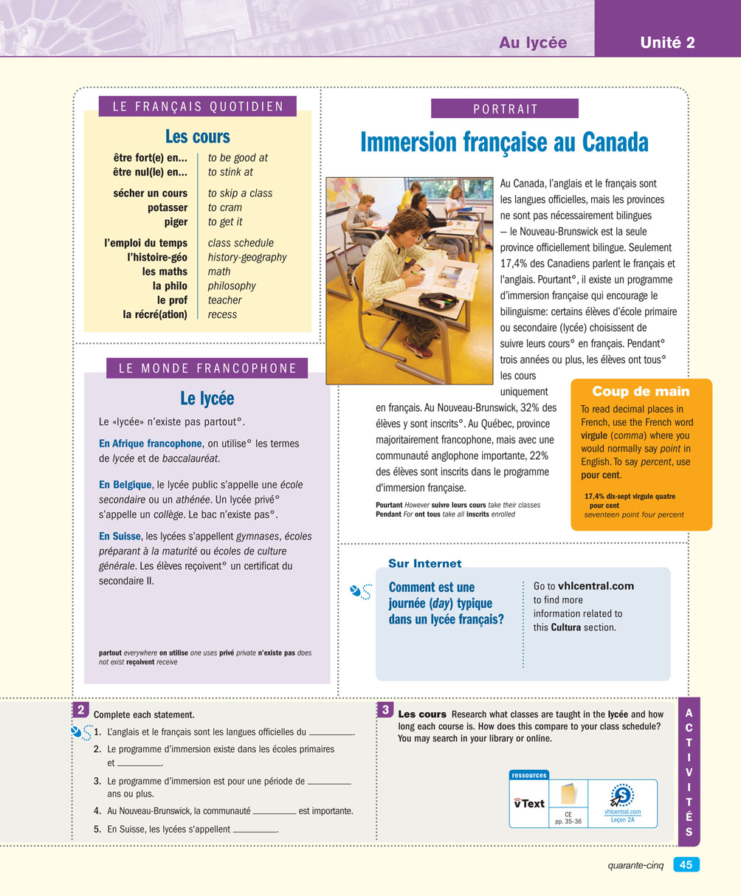

1/ Complete each statement
1.
2.
3.
4.
5.

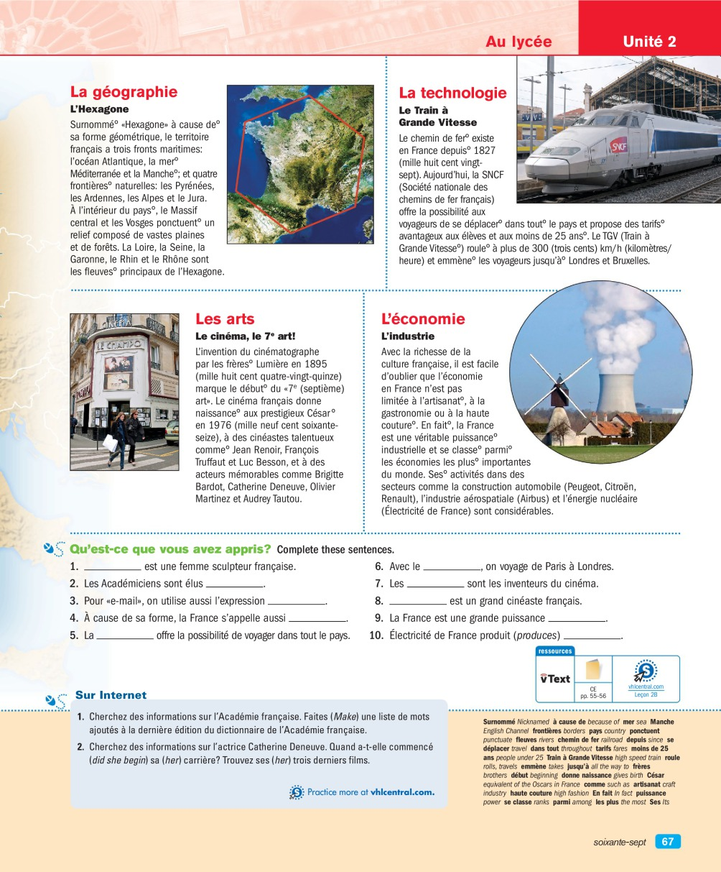

Qu'est-ce que vous avez appris?

1.
2.
3.
4.
5.
6.
7.
8.
9.
10.

